DCN SELF NOTES 23-02-21

**Object ipv4**

Parts of ip addresses:

An ip address consist of two parts:

i.) Netwrok part

ii.)Host part

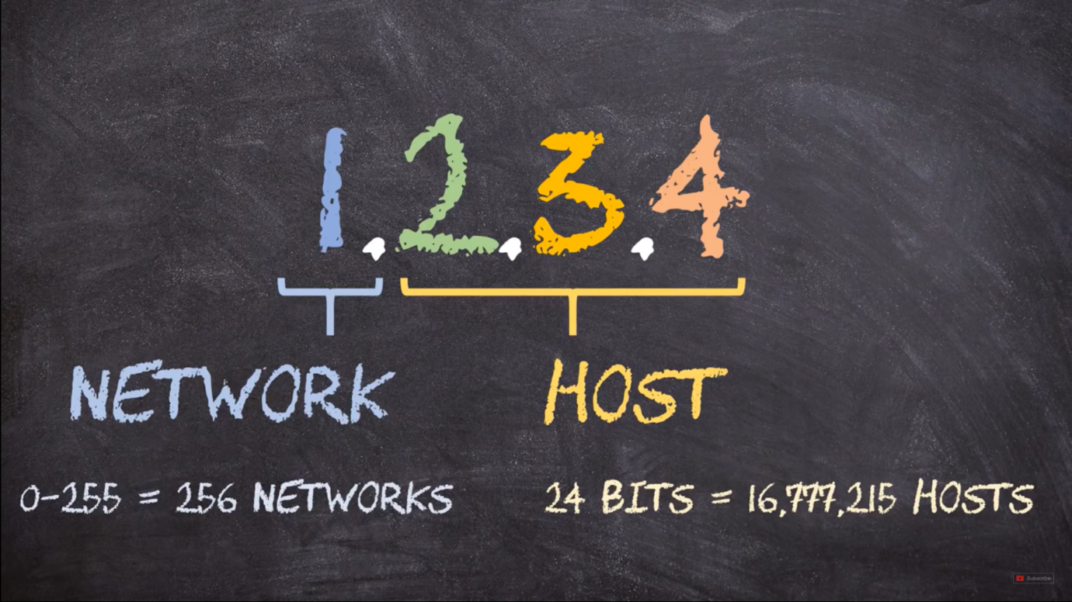

On the basis of network and host part in ip, ips are further divided into classes

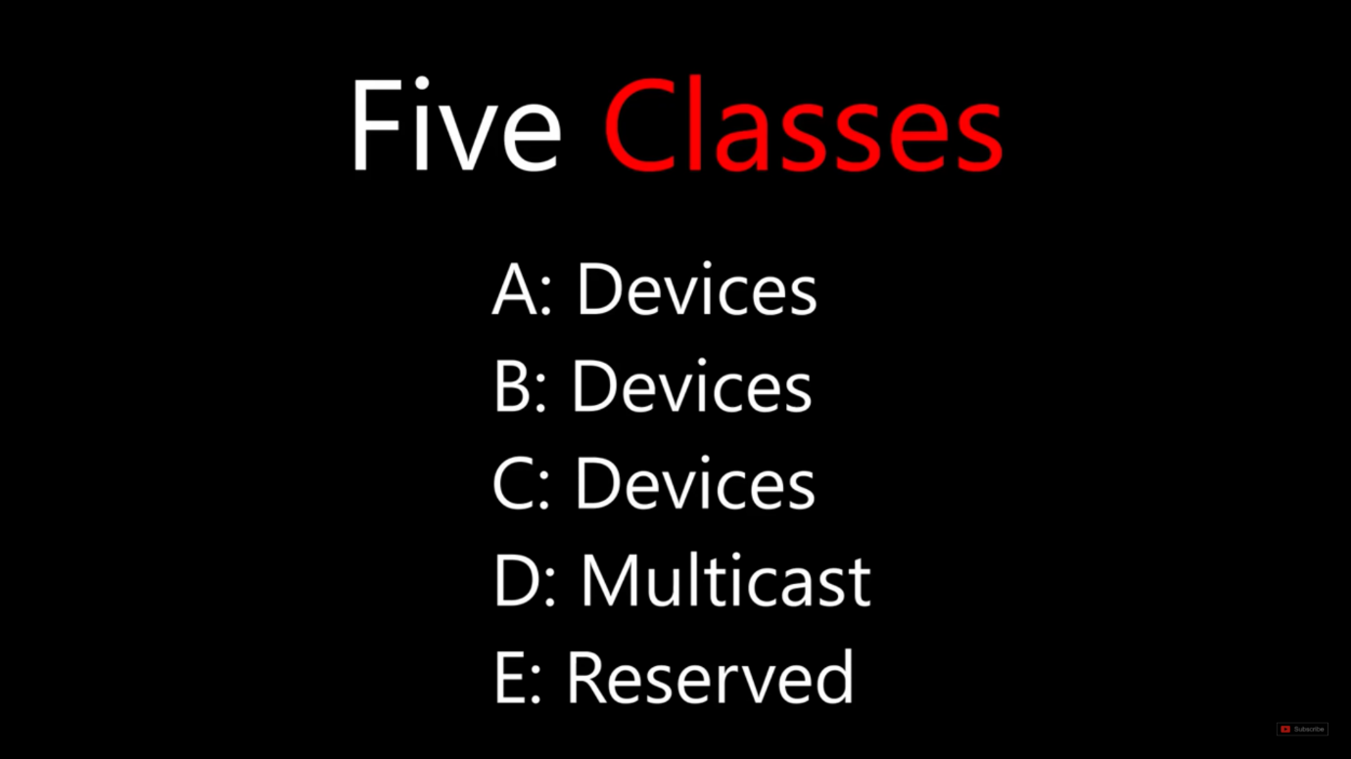

**Class A:->** 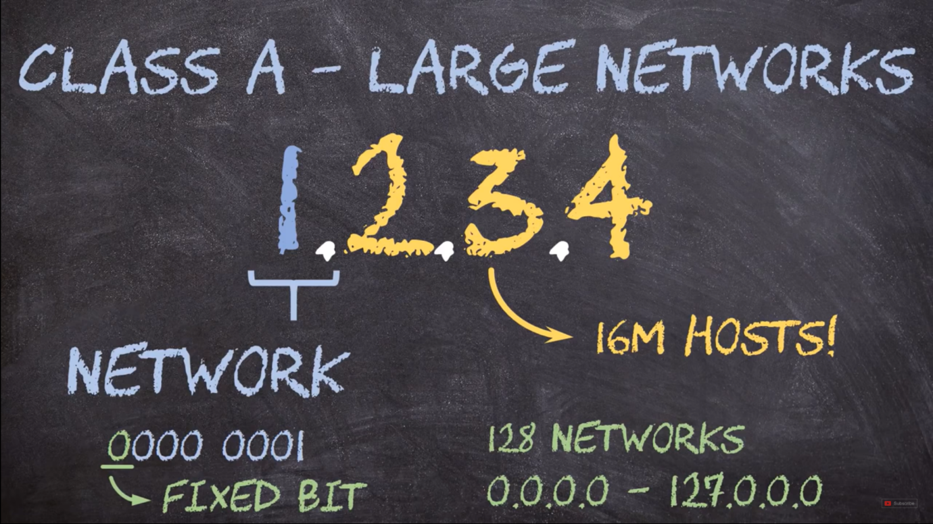

**Class B:->**

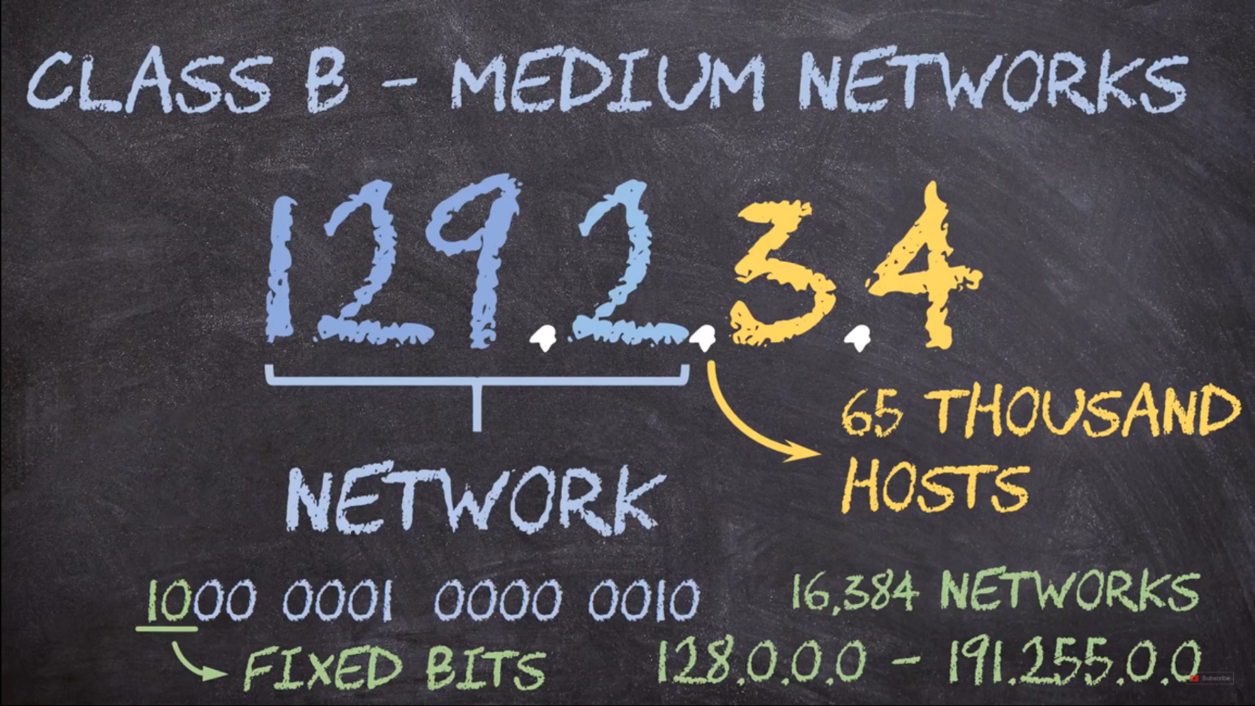

**Class C:->**

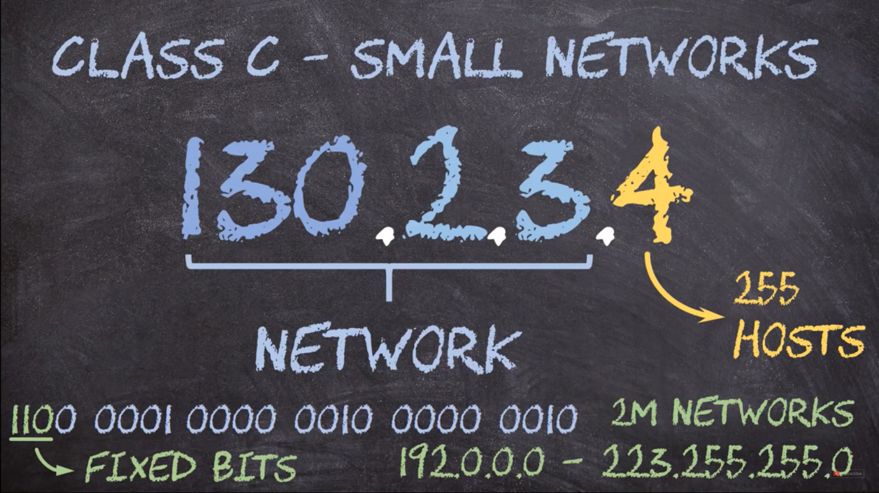

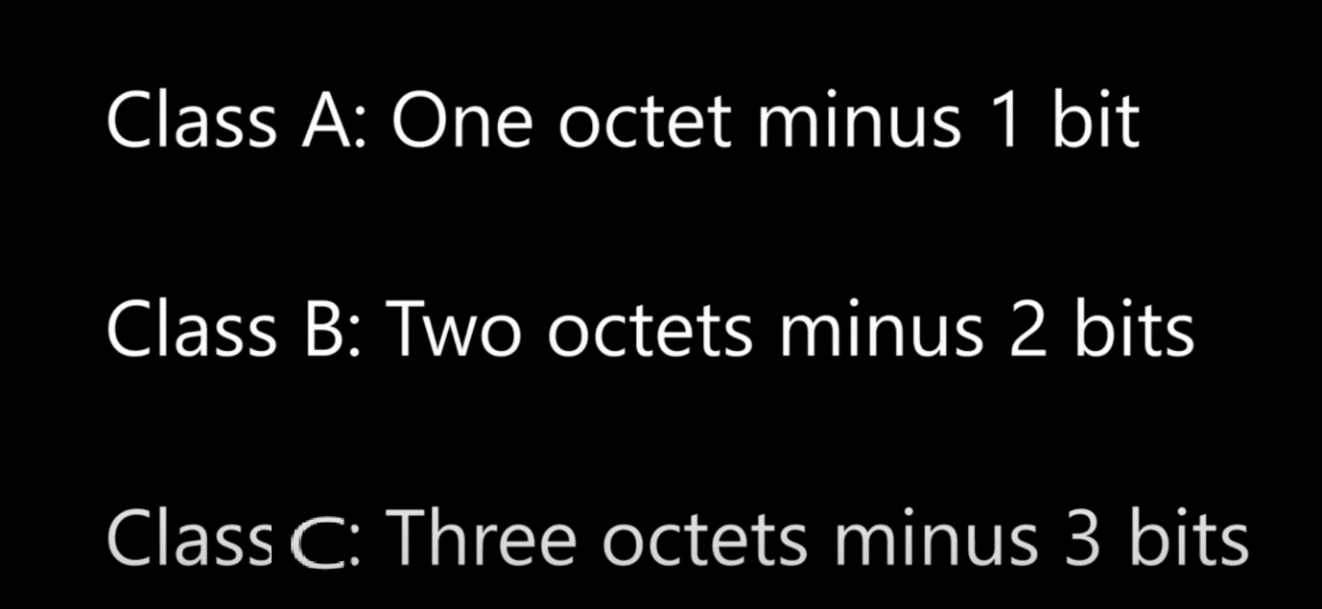

**CIDR NOTATION:> To not write subnet mask each time:**

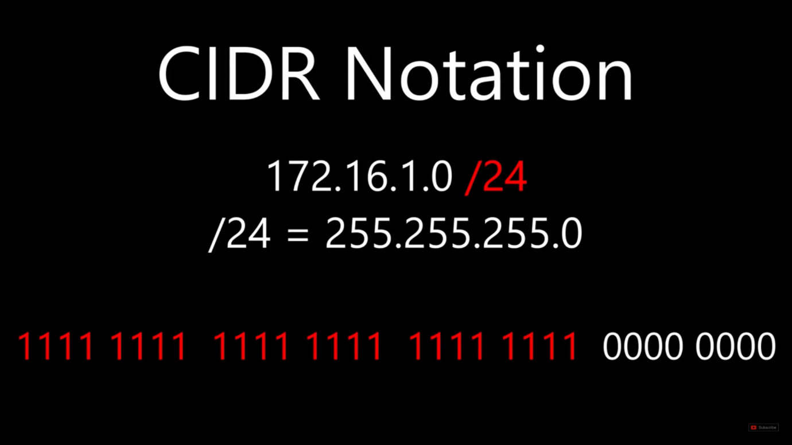

**/24 means first 24 bites of subnet mask is turned on which means it will give 255.255.255.255.0 subnet mask**

**Subnet mask:> The subnet mask also made with 4 octet**

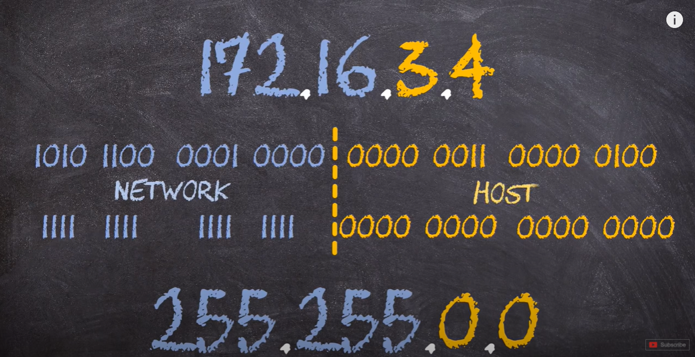

All the 0’s will go for host

It’s also important to notice all the 1’s are go on the left and all the 0’s go on the right.

**The real ability of CIDR is to break a large network into small ones**

**Note:** Devices with the same subnet must be one the same ip network otherwise they can’t communicate

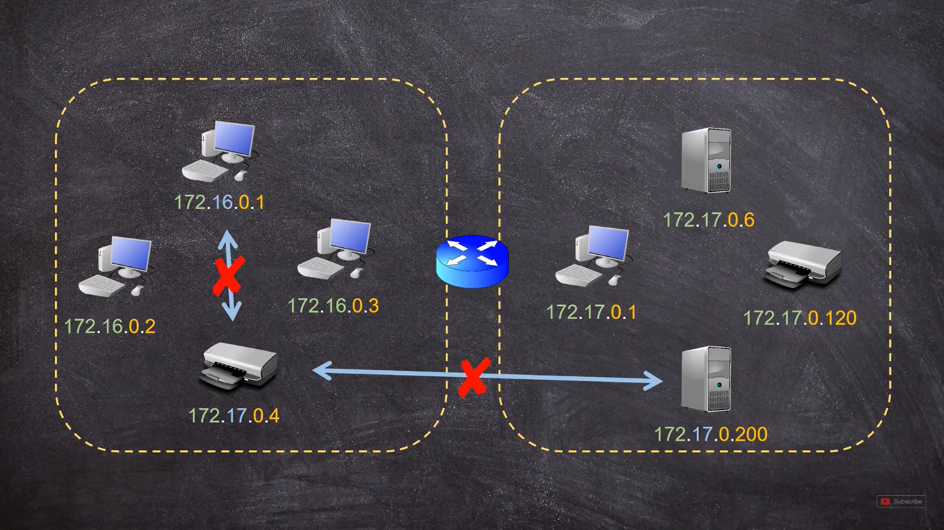

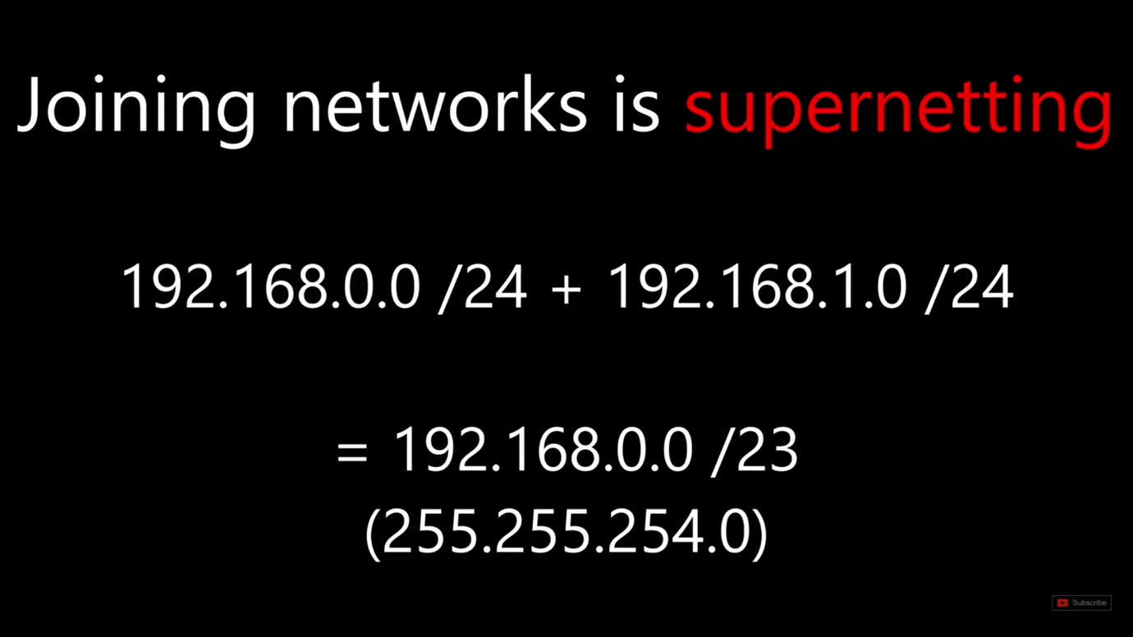

**Doubts:**

**i.) How to calculate subnetmask**

**ii.) How subnet mask divides a large network into**

**small subnetworks**